PROJECT DESIGN PHASE

Date | 02 November 2025
Team ID | NM2025TMlD03628
Project name | Laptop Request Catalog item

IntroductiontoDesignPhase:

The design phase of the Laptop Request Catalog Item project in ServiceNow acts as a bridge between the requirement analysis and the actual system implementation. Its primary objective is to transform the gathered business and functional requirements into a detailed, structured design that defines how the catalog item will function within the ServiceNow environment.

STEPS:
- Creation of new update set:
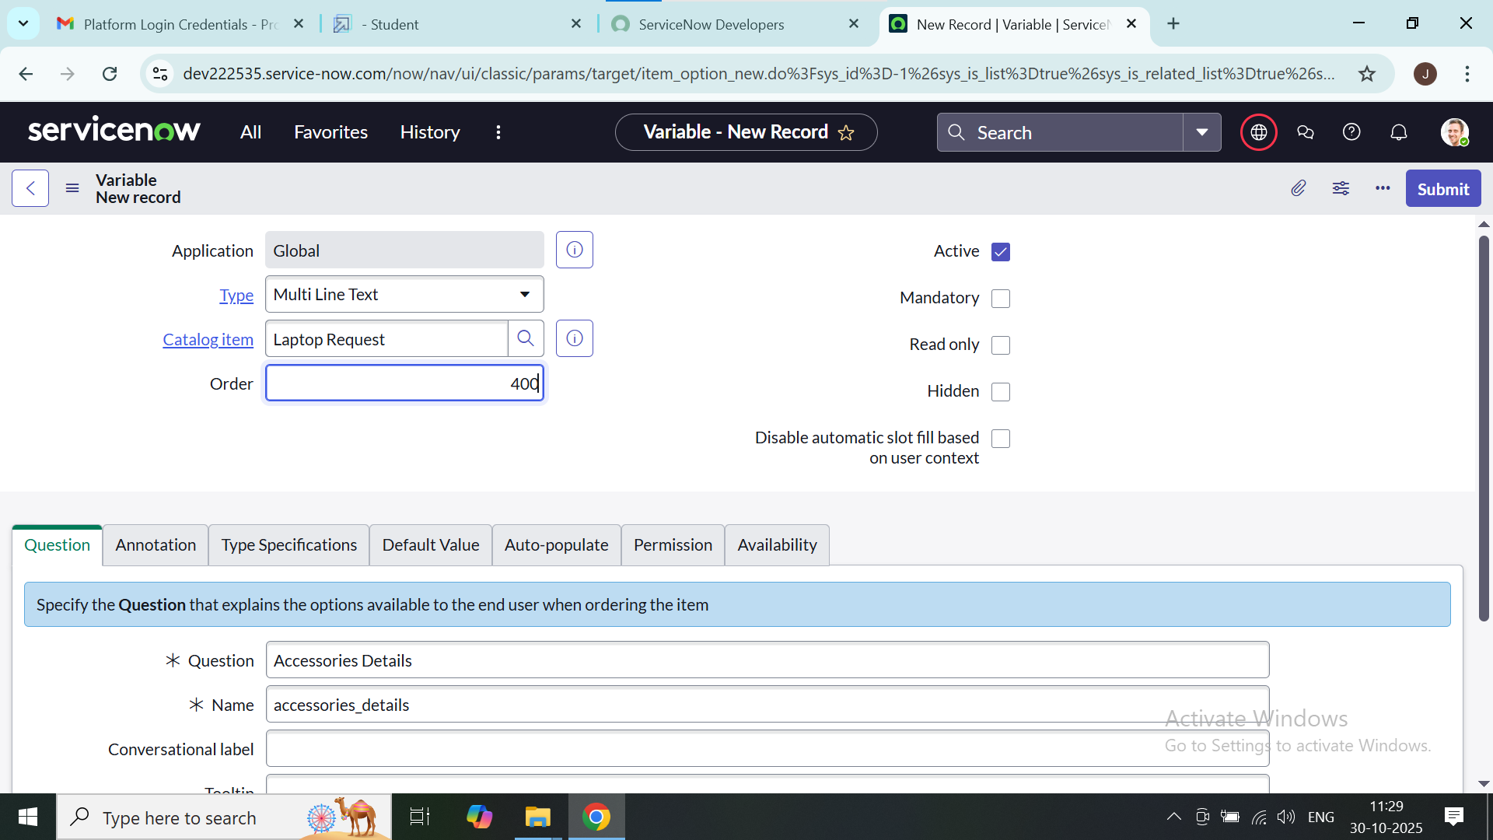
Go to All >> In the filter search for Local Update set > click on New. Enter the Details about laptop

Table creation:
Catalog Items in table:

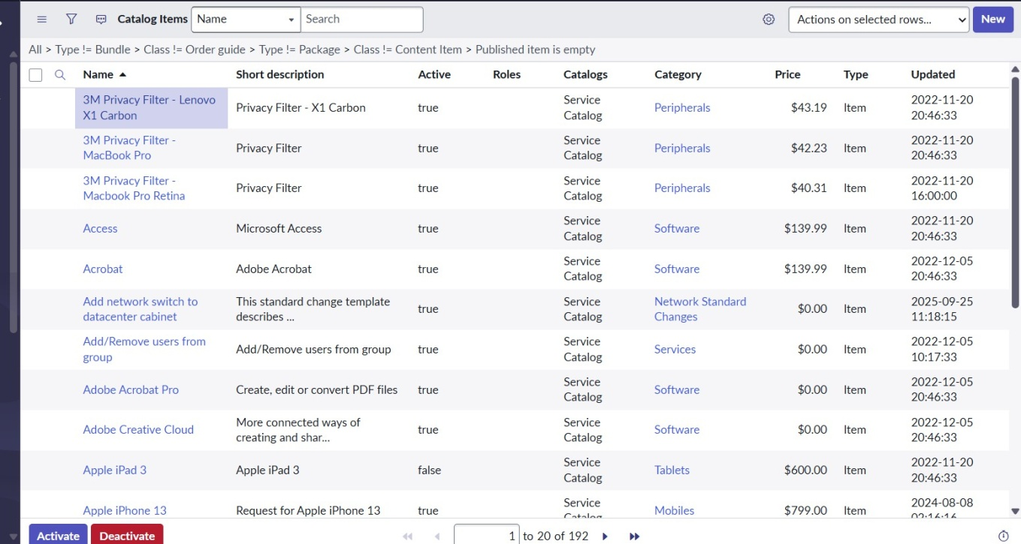
Laptop Request table:

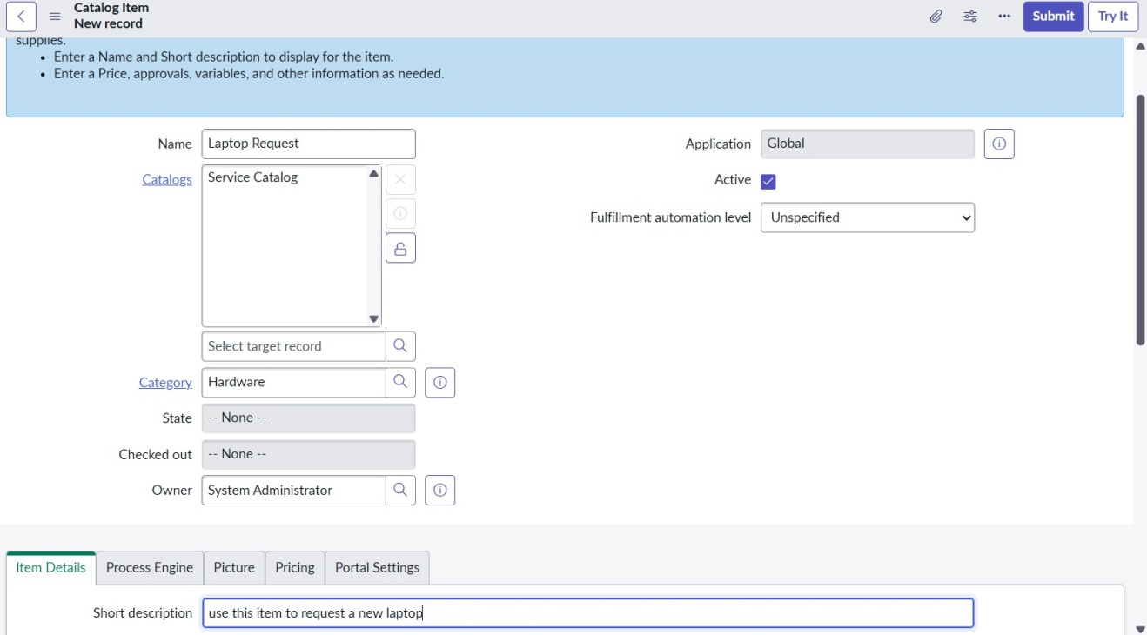

- Add Variables:
- Go to All >> In the filter, search for Relationships >> Open Relationships.
- Click on New.
- Enter the required details.

Variables : Laptop Model

Type: Single line text Name:laptop_model Order:100

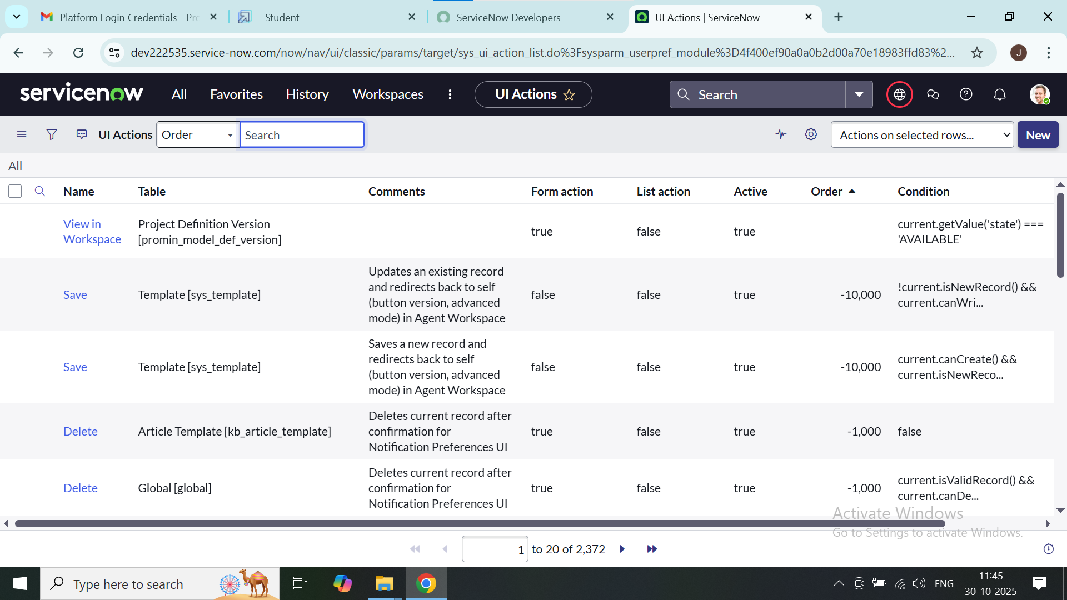

Variables : Accessories Details Type: Multi line text
Name : accessories_details Order:400

4. Click Save

4)Creation of Business Rules:

1. Go to All >> In the filter, search for Service Catalog.

2.Under Catalog Definition, select Laptop Request, then click on New.

3. Enter the required details.

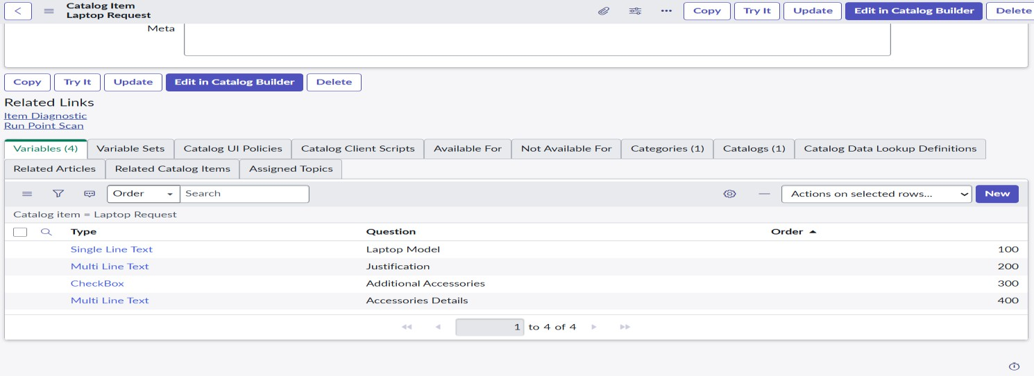

Creation of Ui action:
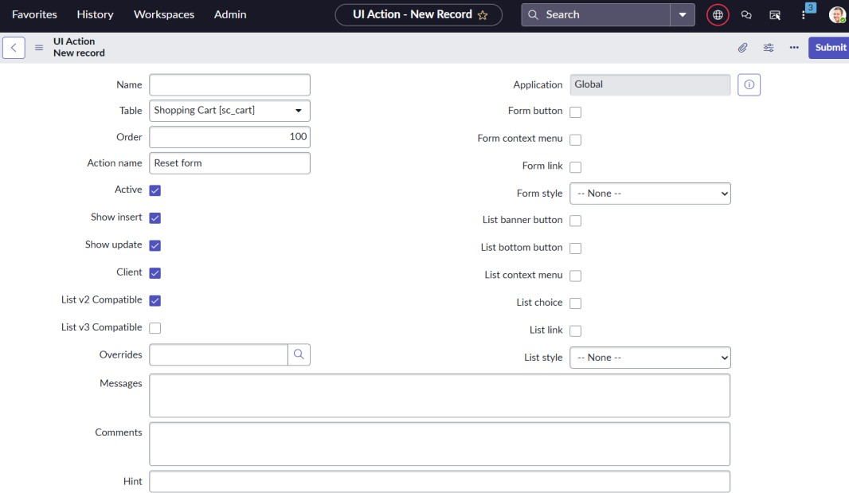

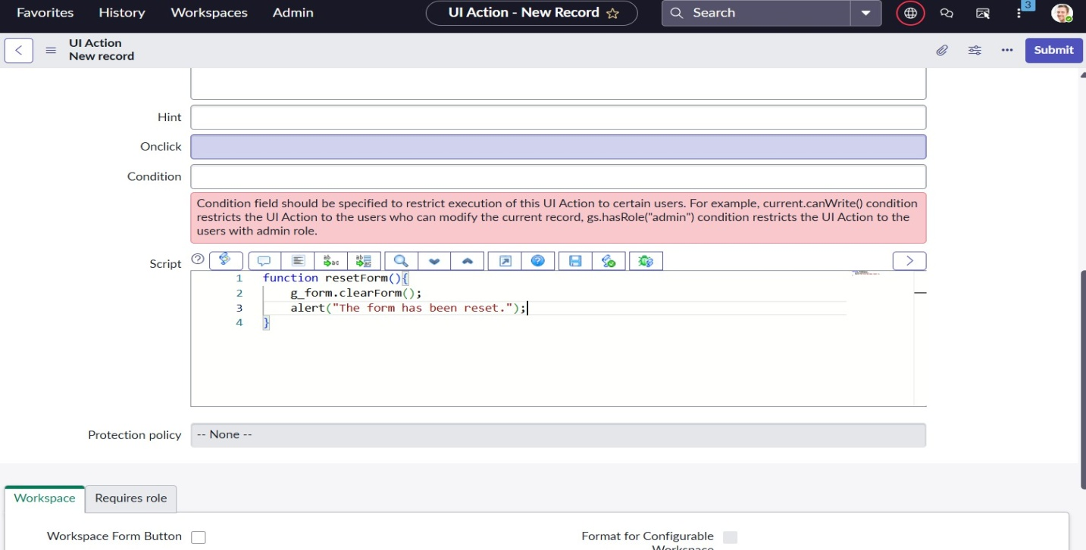

Conclusion of Design Phase:
The design phase has successfully transformed analytical insights from the laptop request process into a well-defined ServiceNow catalog design. The outcome provides a clear blueprint for development, ensuring that the implemented solution will streamline the laptop request process.

